CRAILING, ECKFORD AND NISBET COMMUNITY COUNCIL
2024-2027
Minutes of General Meeting No 11
7-9pm 11th May 2026 Village Hall, Eckford
Chair Charlie Robertson
No |  | ITEM | ACTION
1 |  | CR welcomed everyone to the Meeting.
2 |  | Attendance  Keith Bader KB, Virginia Burbridge VB, Richard Howes RH Katherine Pery KP, Charlie Robertson CR,  In Attendance Councillor Scott Hamilton SH,  Emma Donnelly, Member of the Public
3 |  | Apologies  Councillors, John Bathgate JB, Councillor Scott Hamilton SH, & Sandy Scott SS  PC Carin Tait-Logan CTL, Community Police Officer
4 |  | Approval of Minutes of the Meeting of 12th January. Proposed KB Seconded KP
5 |  | Matters Arising (not covered in the Agenda)  i Security Lighting, Crailing Tofts. Mr Dagg had agreed to see what could be done. It was felt that the situation had already improved.
6 |  | Treasurer’s Report (Appendix 1) Report submitted, discussed & approved. Accounts looking quite healthy.
7 | Community Updates  1 SBC Councillors  There were no updates as the Councillors were unable to be present  2 Crailing  - Crailing Rideout. A piper had been booked for both events at a cost to the CC of £80. He had asked for some details of the format. VB to provide CR with contact details so that a meeting could be arranged to finalise the arrangements.  - Important to publicise both events widely. CR to prepare the information and circulate to the Callants Committee, CEN Website, Jed Eye, Crailing Whats App Group, Nisbet News. KP would arrange for the Quaich and the engraving. Details to be discussed at the next meeting.  3. Eckford  - Grahamslaw Road. The worst of the potholes had been patched and some planings had been placed at the road edges where it was eroding. However, much more was needed. KB to contact Donald Scott to pass this on. KB to send CR contact details of Donald Scott. He would write on behalf of the Council to thank them for what had been done and to ask for the further necessary patching and in-filling to be done.  - Potato Boxes at Wester Wooden. Not much further movement.  - Septic Tank Wester Wooden Cottages. Concern had been expressed about the septic tank that services Nos 5,6,7 & 8 Wester Wooden Cottages. The lid of the tank is cracked and there have been complaints about the smell emanating from it. Furthermore, there were doubts as to when the tank was last emptied. Chair to write to Mr Ramsay, the owner of the tank, asking for the top to be repaired and enquiring about plans to have the tank cleaned out. At the same time, he was asked to raise the issue of the potato boxes.  4. Nisbet  - No issues to report  5. Ulston  - No report. |  | VB  CR  CR  KP  KB  KB  CR  CR
8 | CENCC Ongoing Actions  i President’s Route. No progress.  ii Resilience No issues to report.  iii Kalemouth Bridge. Bridge now reopened for pedestrians and cyclists. Carriageway had a wire mesh covering and barriers down both sides to increase safety  iv Community Place Plans. (Appendix 2) Detailed analysis of responses issued. These contained some very creative ideas and gave significant pointers for action. These will need to be analysed further. SBC had been contacted to see whether some Consultancy time might be made available for this. There will then be follow-up discussions and consultations with the community.  v Defibrillators. Pads had been purchased. There were two offers of sponsorship. KB following one up. CR to check on the other. These would cover the replacement of a defibrillator and a battery. It was important to keep looking for sponsors as the plan for 2026/7 required further significant expenditure.  vi Distillery Visit Still on the cards. The Distillery in full operation but still had some ‘tidying-up to do before welcoming visitors. August suggested as a possible time. |  | CR,KB,RH  KB  CR  ALL
9 | New Business  i AGM Arrangements.  Agreed to shift the date of the AGM from Monday 15 June to Monday 22 June. CR to inform SBC and to advertise the change on the website. CR to arrange advertising for the AGM. CR to prepare the annual Report, KP to prepare Accounts for the year.  CR to invite a speaker from a local enterprise to talk about their business. The purpose being to highlight the work of businesses within our community.  ii Renewable Energy Map SBC. E-mail circulated. Appendix 3  iii Review of Financial Support for CCs. E-mail circulated. Appendix 4  iv Funding Opportunities e-mail circulated. Agreed to look into this with reference to our Place Plan. Appendix 5 |  | CR  CR  CR  KP  CR
10 | Planning Applications  i Plots 1&2 Land South of Wester Wooden Farm Cottages, Eckford. Response submitted
11 | AOCB  i Dates of Meetings 2026-27  CR tabled a draft Meeting schedule for 2026-27. Agreed to discuss and agree this at our next Meeting |  | ALL
12 | DONM AGM & Meeting 12  Monday 22 June 2026 7.00-9.00  Lothian Hall, Crailing

Appendix 1
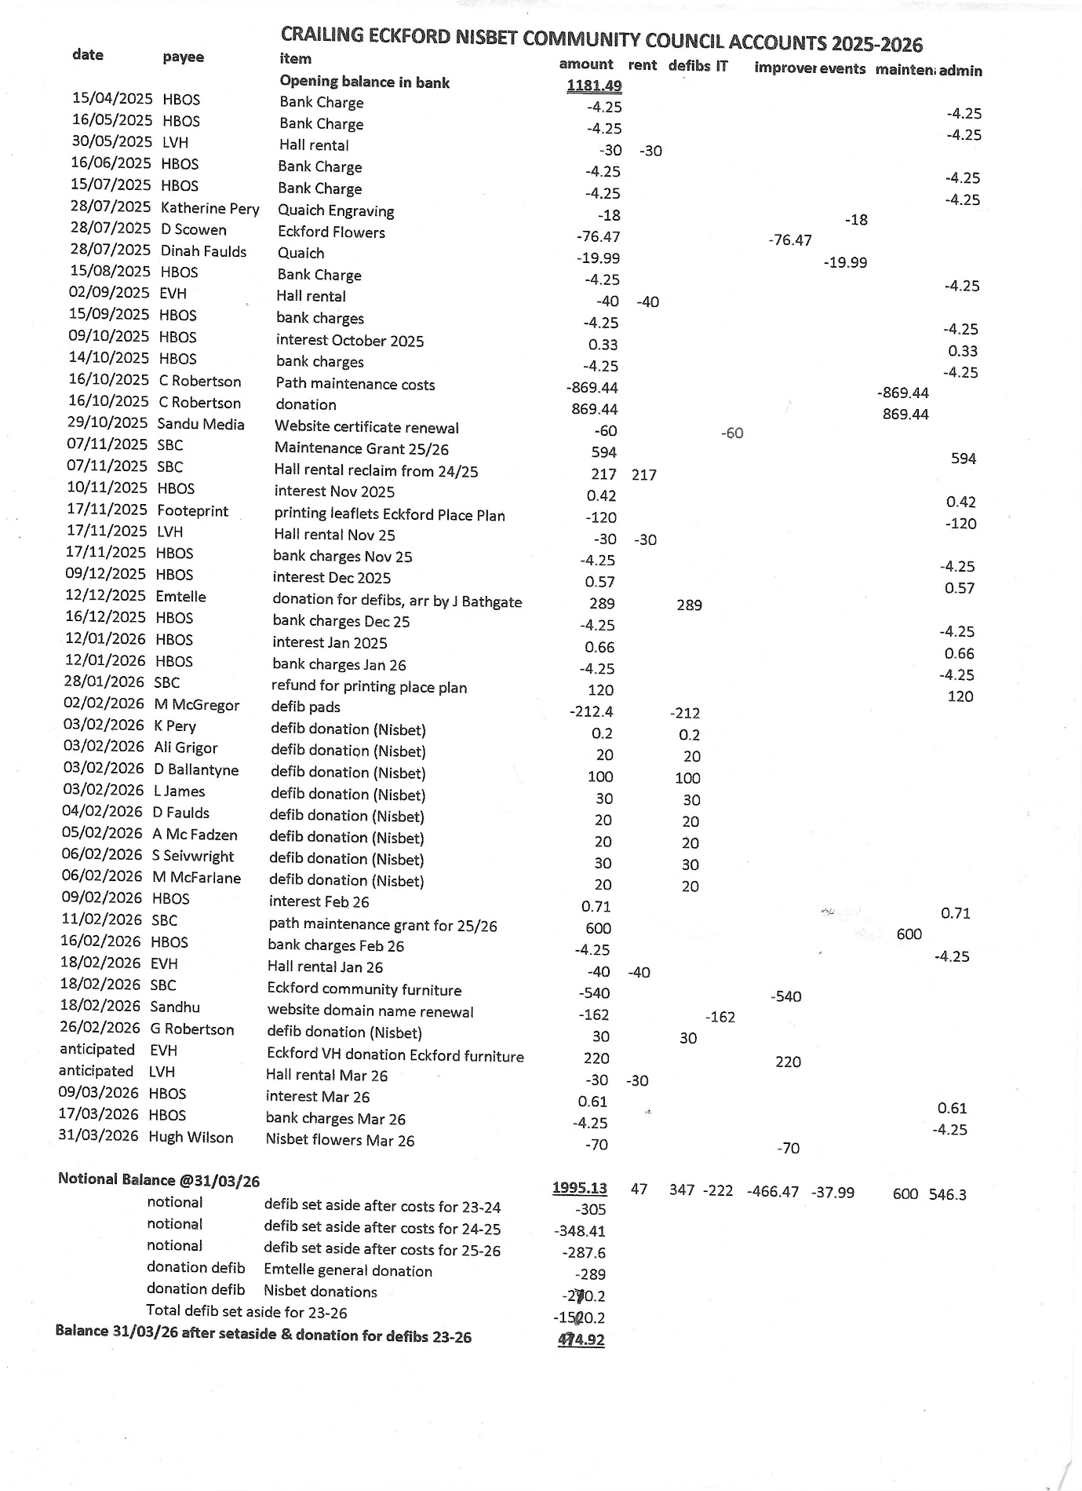

Appendix 2

CRAILING ECKFORD AND NISBET COMMUNITY COUNCIL
ECKFORD COMMUNITY PLACE PLAN IDEAS SHEET ISSUES HIGHLIGHTED
FACILITIES | ECONOMY & EMPLOYMENT | HEALTH
HALL  New Hall 3  New Hall on site of Black Barn 3  Feasibility study on New Hall  New Hall not required  Refurbish/Extend Present Hall 6  New Hob in Hall  More Power Points  PLAY AREA  Play Area 11  Don’t need a play area 3  OTHER  BBQ Area  Pub  More Regular Bus Service  Resite War Memorial  Community Hub  Coffee & Chat Events  Village Focal Point  Post Office | WORK  More work Opportunities - good idea  More Work Opportunities – badly needed  More Work Opportunities – Not viable/practical 2  What work is there  More folk working in the Community  Develop the Young Workforce  What work is there  BUSINESS  Need to attract New Businesses (Role for SBC & CC  What will attract investment  Encourage Small Businesses  Small Business Units  Small Business Hub  Use redundant farm buildings  Industrial Units at Wester Wooden and Grahamslaw  Industrial Units not practicable 2  OTHER  Make Grahamslaw Distillery a Visitor Attraction – create jobs  Village Shop  Monthly Business Discussions  Keep Village small  Pub | PATH NETWORK  Extend Walking Trails 5  Link Eckford Paths to Bowmont Forest  Restore Historic Paths  Path from Grahamslaw to Bowmont Forest  By-pass Wester Wooden Farmyard by a path round Wooden Loch 2  Restore Kirk path from Eckford to Easter Wooden and Cessford.  Pedestrian Bridge across the Kale at Grahamslaw to extend Paths network  Provide an off-road path for Jubilee walk from Village to Morebattle cross roads 2  Path from Wester Wooden to Village 8  Path from Wester Wooden to Morebattle X Roads.  Path from Village to River Teviot  Improve track from Loaning to Wooden Loch  Path network extended to include places of interest and historic sites 2  More seating on Walks 4  Parking space for walkers  Better signage for walks 2  Paths not necessary  Improve access on Paths 3  Wheelchair/Disabled access to paths  Establish Walking Groups  Exercise areas on Paths  PAVEMENTS  Pavements in the Village 6  Not enough people for Pavements  OTHER  Outdoor Gym/ Fitness Area 2  Exercise Area inside and outside the Hall  Fitness Classes in the Hall  Community Planters  Keep Green Spaces

LAND USE | HERITAGE | HOUSING
FARMERS & LANDOWNERS  Planting Native Trees instead of Commercial Forestry  More trees round fields in the Hedgerows  Plant more trees  Repair Hedgerows  Stop cutting down native trees  Increase set-aside payments to encourage farmers to use land for natural forests and for wildflowers.  Leave field edges for paths and nature  More wildlife and wildflower areas  Land available for Community use and environmental benefit.  Community woodlands and Orchards.  Better communication on land use changes  NATURE RESERVES  Need Reserves /Natural Forests to improve/maintain Diversity.  Establish a Reserve at Wooden Loch 5  Reserves struggling in the Borders  WOODEN LOCH  Wooden Loch Develop  Wooden Loch Tidy up/Remove reeds  Wooden Loch: Fishing; Bird Hide; Wild Swimming; Picnic Area 2  Path round Wooden Loch 4  Wooden Loch replace Jetty  Loch Committee to oversee  OTHER  Picnic area by the river  Bird Hide up the Loaning  Owl & Bat Boxes  Pond/animal habitat to encourage wildlife  Less trimming and strimming  More ‘untidy’ (natural) areas | KALEMOUTH BRIDGE  Shame on SBC, An Historic Structure allowed to deteriorate. 2  Cat A listed structure, MUST be restored  Restore KB for Motorists 4  Restore for Light Vehicles  Reduce Community Charge for Ormiston Residents if no vehicular access.  Restore KB for pedestrians and Cyclists 16  Too expensive to restore fully  Ormiston area much quieter with Bridge closed.  Speed bumps/speed limit at the Bridge  Improve Signage at the Bridge  Plan to Celebrate the Bi-Centenary  Information Board about the Bridge in the Village  Bridge accessible for Wheelchairs  Create a path to link Bridge with other Historic Sites  OTHER  Restore Grahamslaw Doocot 2  Promote Haughead and provide access  Plant Heritage Fruit Trees  Tidy & refurbish Mill Pond at Easter Wooden  Use Hall as a Heritage & Visitor Centre.  Restore and publicise Watchtower in Eckford Kirkyard  Habbie Kerr’s Grave Identify and provide access  Restore Loaning burn & water feature  Provide Interpretation Boards at Kirkyard | FOR  More Houses needed 3  Yes, if needed  Need sympathetic development suitable for a small community  Space for 10-12 Houses at the West end of the Village  Need Housing to rent  Need Affordable Housing  Affordable 3-bedroom houses  How do you ensure that Affordable Houses remain for young people when they are re-sold  Make provision for young families 7  Young families a priority  Create a better spread of age groups  Create new houses from old farm buildings  AGAINST  Eckford IS a retirement Village and that is fine.  Keep Eckford small.  No new builds  Not sure if young families would want to live here

PROGRESS TO NET ZERO | TRANSPORT | TRANSPORT 2
POSITIVE  Offgrid Energy Production/storage for the Community  - Solar 7  - Wind 6  - Anerobic digestor  - Ground source  - Biomass  - Funding for Domestic wind turbines  Planting Native trees  Grants for Houses  Free Charge point in the Village  Bottle Bank in the Village  Community Allotments  NEGATIVE  No Pylons  No windfarms  Unattainable and Expensive  Local area unsuitable  Don’t believe in it  ANY development in the Village is contrary to Net Zero | ROADS  Improve road from Village to Morebattle junction  Provide passing places on the road to Bowmont Forest  Resurface the Grahamslaw Road  Restore verges 1  Maintain C class roads  Get the potholes filled  Make Roads into the Village Access only  Improve Western junction with the A698 inc. lighting?  Improve sightlines at W Wooden Junction and at Eckford Cross-Roads  Resurface the Well Road  TRAFFIC CALMING  Traffic Calming  - Village 11  - Grahamslaw  - W Wooden Junction 3  - W Wooden Road 3  - Where houses sit beside road  - On A 698  Is calming really necessary  Good luck with calming  Narrow road entrances to Village to reduce speed 3  20 MPH signs extended to W Wooden turn-off and to Mosstower  . | TRAFFIC CALMING (ctd)  Speed ramps at either end of the Village 2  Electronic speed register.  Bigger Slow signs at the Morebattle end of the Village  20 MPH is enough traffic calming  No Speed Bumps 2  PATHS  Create a footpath/Pavement in Village  No path on B6401 from Easter Wooden to x-roads, v. dangerous  Footpath/ on A698 from Old Manse to Kalemouth  BUSES  No bus service on B6401  Dial-a-Bus service  OTHER  Extend village boundary to W Wooden  Off-Road Parking in the Village  Loaning tarred  Repair Loaning outside village cottages.

OTHER | OTHER 2
VILLAGE  Must maintain Eckford as a Centre of Quiet life.  More flowers around the Village and roads  Village Welcome signs  Remove Black Barn; Restore to farmland  Demolish Black Barn  No Change in the Village  HALL  Classes for Hobbies in the Hall  Carol Singing at Christmas  Coffee Mornings, Craft Fairs, Get togethers in the Hall  Film Nights in the Hall (Many don’t like driving any distance at night)  WiFi in Hall  New Hob for Hall  Make Village Hall more homely, rather than a school Hall  More Hall activities  OTHER  Get SBC to invest in infrastructure to bring in Businesses from outwith the Region to create Employment  Open a Farm Shop  Café linked to the A698  Community Bulk Buying | Bottle Bank  Remove the Potato Boxes  Ormiston Bins have to be taken to the Bridge, a long distance and the bins are used by others.  Bin Collection issue W Wooden  stablish a Whats App Group  Publish an Eckford History  Cut out Fireworks in the Village  Light pollution from Crailing Tofts

Appendix 3
Dear Sir/Madam,

I write to draw your attention to the Scottish Borders Renewable Energy Developments Map which has recently been updated. This map replaces the former Wind Farm Map and now covers a wider range of renewable energy technologies. The map is updated quarterly, and the most recent (March 2026) includes all relevant planning applications received up to 10 March 2026.

The Renewable Energy Developments Map can be viewed at this link: SBC Renewable Energy Map (MAR 2026)

We would welcome feedback from users of the map. As part of our ongoing work to improve its accessibility and usefulness, we are inviting users to complete a short survey to help us better understand how the map is used and identify opportunities for further improvement. The survey should take less than one minute to complete.

Survey link: Renewable Energy Developments Map Questionnaire

Please feel free to share this survey with others who may also use the map or have an interest in renewable energy developments.

Thank you for your time and input.

Yours faithfully,

Sarah Morton
Research Planner
Planning Policy & GIS
Scottish Borders Council
t: +44 1835 828546

Appendix 4
From: Community Engagement <CommunityEngagement@scotborders.gov.uk>
Sent: 31 March 2026 09:03
To: Malster, Clare <CMalster@scotborders.gov.uk>
Subject: [OFFICIAL] Review of Financial Support to Community Councils - call for nominations

Dear Community Council

You may be aware that it was three years since the financial support provided to community councils was reviewed. Following discussion by the working group the following recommendations were agreed and implemented in 2024/25:
a) Increase the annual community council support grant by 10% representing a budget increase of £4,970,
b) Review the annual support grant every three years,
c) Limit spend of the annual support grant to operational matters in the first instance and other initiatives thereafter,
d) Disallow community councils from using the annual support grant to fund third party organisations,
e) Cover the cost of all community council insurance premiums, capped at the current level of assets and events, at an additional cost of approximately £6,000 for 2024/25 allowing for annual increases thereafter, f) Increase the maximum local community paths maintenance grant to £600 per applicant, representing a budget increase of £5,100,
g) Officers to support a review of Scottish Borders Community Councils’ Network to consider the establishment of locality-based networks in consultation with community councils,
h) Maintain SBCCN annual grant at current level to be reviewed once the future of SBCCN has been agreed, and
i) The wider support available to community councils to be reviewed.

With reference to recommendation g) above a review of options for a replacement for Scottish Borders Community Councils’ Network (SBCCN) has been incorporated into the review of non-financial support which is currently taking place. With reference to recommendation h) above, no increase has been made to the SBCCN grant of £1,250 which has not been paid since 2021/2022.

Council agreed last week that the next review of financial support will take place in 2026/27 with a view to any changes being implemented in 2027/28. The Working Group carrying out the review will consist of Scottish Borders Councillors and Community Councillors. Councillor Cochrane, who will chair the Working Group, is working with Jenni Craig (Director – Resilient Communities) to appoint an Elected Member, from each locality, to the working group.

In order to appoint Community Councillors (one to represent each locality) to the Working Group, Community Councils are asked to consider nominating a Community Councillor from their membership to join the Working Group on behalf of the relevant locality.

It is expected that meetings will take place via MS Teams, early evening, approximately every six weeks and anticipated that the work will commence late May/early June with a view to taking any recommendations back to Council by the end of 2026 (calendar year).

If someone from your community council is both willing and able to take part, I would be grateful if you would forward me their name and email address by Monday 27 April. If there is more than one nomination in a locality the community council representative will be selected at random from those who applied.

Please send your nominations not: communityengagement@scotborders.gov.uk

Kind regards

Clare

Clare Malster
Community Co-ordinator
Communities and Partnerships Team, Resilient Communities
Scottish Borders Council
Tel: 01835 826626 (direct line)

Appendix 5
Good morning everyone

We are bringing this opportunity to your attention if any of your groups have a project/initiative that may be applicable. There are links and an email address below to assist with any queries.

Funding Opportunities Scheduled to Open Soon

Community Led Local Development (CLLD) funding for the 2026/27 period in the Scottish Borders will open for Expressions of Interest on 8th April 2026.

Supported by the Scottish Government, the CLLD programme provides financial assistance for community-based initiatives that deliver benefits to local groups, communities, and businesses.

Grants of up to £25,000 will be available through the two CLLD funds, which are open to small businesses, private sector organisations, enterprise bodies, third sector organisations, and community and voluntary groups.

The Growing the Economy Fund is open to businesses with a clear intention to generate profit—this is the main eligibility requirement for applicants.

To be considered for the Community Development Fund, projects must demonstrate a clear contribution to at least one of the following priority themes:
- Net Zero
- Poverty Alleviation
- Improved Public Services and Tackling Exclusion

Organisations previously funded under the programme may apply for support for new projects, although priority will be given to applicants who have not received funding before.

The funding will be delivered through a two-stage application process, beginning with the submission of an Expression of Interest (EoI), followed by a full application. Only two funding rounds will be available, closing on 20th May and 1st July 2026. All grant funding must be spent by 28 February 2027.

The Expression of Interest window will be open from 8th April 2026.

To arrange a meeting to discuss your project proposals and assess eligibility, please contact the team at: clldgrants@scotborders.gov.uk.

Further guidance and the Expression of Interest form are available on the Council’s website at:
Funding Support – Expression of Interest Form | Grant Funding for Community Projects | Scottish Borders Council (scotborders.gov.uk)

Hopefully this is something that may assist a number of your groups, communities etc.

Kind regards

Neil Inglis

Neil Inglis

Assistant Emergency Planning Officer

Emergency Planning Department
Scottish Borders Council
Bowden Road
Newtown St. Boswells
Melrose
Roxburghshire
TD6 0SA

Email:- eps@scotborders.gov.uk

Tel: 01835 825056

Appendix 3

