CRAILING, ECKFORD AND NISBET COMMUNITY COUNCIL
2024-2027
Minutes of General Meeting No 9
7-9pm 12 January 2026 Eckford Village Hall
Chair Charlie Robertson
No | ITEM | ACTION
1 | CR welcomed everyone to the Meeting.
2 | Attendance  Keith Bader KB, Virginia Burbridge VB, Richard Howes RH Katherine Pery KP, Charlie Robertson CR,  In Attendance Councillor John Bathgate JB,  Chris Green, Member of the Public
3 | Apologies  Councillors, Scott Hamilton & Sandy Scott SS  It was noted with sadness that Jock Henderson, Hon Auditor to the Community Council, had passed away just before Christmas. Jock had been a loyal supporter of the work of the Community Council and had audited the books for at least the last 40 years.
4 | Approval of Minutes of the Meeting of10th March. Proposed KB Seconded KP
5 | Matters Arising (not covered in the Agenda)  Nil
6 | Treasurer’s Report (Appendix 1) Report submitted, discussed & approved. Accounts looking quite healthy.  SBC had apologised for the delay in sending out the Paths Grant and the reimbursement of the Place Plan Leaflets’ printing costs. There had been a welcome donation to the Defibrillator fund from Emtelle and our thanks to be expressed. There was a lengthy discussion on Defibrillator replacement (reported under 8v). It was noted that the interest on our account would not equate to the monthly Bank Charges. JB agreed to look into whether this was something that SBC could help CCs with. Treasurer to seek out a new Auditor. | KP  JB  KP

7 | Community Updates  1 SBC Councillors  - Live Borders JB reported that the review of the work of Live Borders had been completed. There had been an additional grant from SBC and a new Chief Executive was in post. They were already making savings. Following the Review there had been only one building closure – St Ronan’s Wells. Other buildings had been granted extensions until 2029 to see if revised management structures and community takeovers might be possible.  - Jed Swimming Pool. Following consultations, a large number of people had indicated that they would use the pool. New management group in place. A proposal and a draft business plan were ready to be implemented. SBC giving 5 years of support funding. This will start in year 1 at £115,000 but will decline over the five years to 60% of that figure. If everything approved the Pool could reopen in the late spring.  - Jed Town Hall. Hopes that this would be run by the Community. Borderland funding to be investigated.  - Jed Walking Festival, September. Walks may come to our area.  - Jed Library, High Street. Reopening under private ownership.  2 Crailing  - Wall. SBC had now agreed to repair the wall to its previous height. However, there was no money in the budget for this work to be carried out in 2026/7  - Crailing Rideout. A Meeting had been held with Lindsay Wilson and a proposal for the Callant’s Visit agreed. Lyndsay to discuss this with the Callant’s Club before it can be finalised.  - With the retirement of Blairs in Kelso, the engraving of the Callant’s Quaich was raised. KP to look out for other possible engravers.  3. Eckford  - Grahamslaw Road. No progress to report. Road deteriorating. JB to look into this. KB to supply photographs for him.  - Potato Boxes at Wester Wooden. Pile now well down.  - Christmas Lights. The Hall had been decorated again with Christmas Lighting. The lights had originally been purchased with a Covid grant. Neighbouring householders also put up lights and the Village looked bright and cheery at a dark time of the year.  4. Nisbet  - Street Lighting, Screens for some lights agreed. KP to follow up.  5. Ulston  - No report. | KP  JB  KB  KP
8 | CENCC Ongoing Actions  i President’s Route. Steady but slow progress.  ii Resilience We have been fortunate that we have not needed to activate our resilience groups this winter.  iii Kalemouth Bridge. No report  iv Community Place Plans. Ideas Sheets issued and collected in. The 3 Eckford Councillors will collate and report the results  v Defibrillators. Agreed to go ahead with the purchase of a new defibrillator for Eckford. The existing one, which was still working, would be maintained as a spare. CR to write to Mr Dagg to explain that we are making the purchase and to invite him to make his previously promised donation to the fund. CR issued a Planning Sheet for Defibrillator Replacement and running costs. This gave an outline for the next 10 years. KP completed it in draft for further discussion. This will be useful for seeking further donations and sponsorship. (Appendix 2). There was a discussion as to whether the CC should be responsible for funding defibrillators. It was agreed that the CC admin grant should NOT be used to fund them. Community fundraising and sponsorship to be further investigated.  vi Community Beat Officer. PC Carin Tait Logan promises to attend our next Meeting.  vii Street Furniture Refurbishment, Eckford. Eckford Village Hall had agreed to contribute £220 towards the costs. CR to follow this up. SBC were now pressing for payment. Treasurer to make the payment when the Paths Grant comes in.  viii Distillery Visit Grahamslaw Distillery now in operation. They will contact us when they are ready for a visit.  v Fibre Optics Upgrade Progress still very slow. Clear that the problems are wider than CEN | CR  CR  KB  RH  KP  MMG  CR  CR
9 | New Business  i Registration of Jedburgh Place Plan. As part of the Registration of their Place Plan Jedburgh CC are required to contact Neighbouring CC to seek comments. (Appendix 3). Agreed to contact then to offer congratulations on the preparation of their plan and to wish them well in implementing it.  ii People v Pylons. Further information (including some visual material) issued to Councillors via e-mail. (Appendix 4)  iii Renewables and the erosion of Local Democracy. (Appendix 5) The Council will be represented at a forthcoming Meeting in Jedburgh Town Hall – where 40 CCs will be represented - to discuss this issue.  The member of the public present expressed his reservations about the Council’s support for items ii and iii above. | CR  CR  KB  KP
10 | Planning Applications  i Nil
11 | AOCB  i Borders Tree Grant Scheme. Information issued (Appendix 6)
12 | DONM Meeting 10  Monday 09 March 2026 7.00-9.00  The Lothian Hall, Crailing

Appendix 1
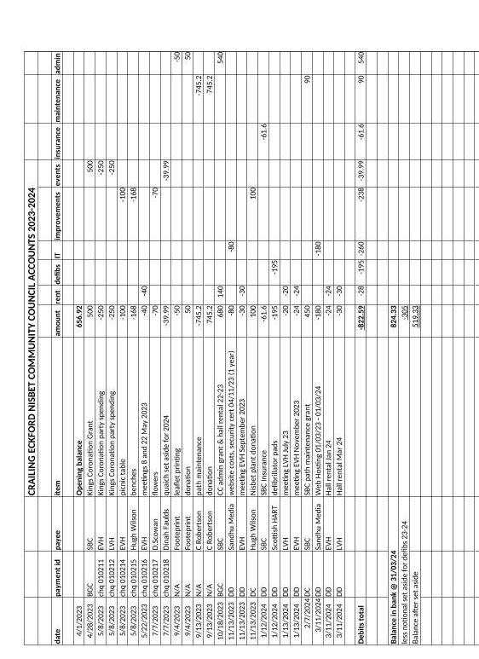

Appendix 2
CRAILING, ECKFORD AND NISBET COMMUNITY COUNCIL
Defibrillator Replacement Schedule and Costs
Year  Financial Year  01 April-31 Mar | Defibrillators Cost £990 |  | Batteries Cost £289 |  | Pads Cost £70 |  | Other |  | Total
Year  Financial Year  01 April-31 Mar | Place & Number | Cost | Place & Number | Cost | Place & Number | Cost | Place & Item | Cost | Total
2025/6 | 1 E | £990 |  |  | 3 C,N,U | £210 |  |  | £1200
2026/7 | 1 C | £1,000 | 3 C,N,U | £867 |  |  |  |  | £1867
2027/8 | 1N | £1050 |  |  | 4 C,N,U | £360 |  |  | £1410
2028/9 |  |  |  |  |  |  | U Cabinet | c£1,000 | £1,000
2029/30 | 1U | £1100 |  |  | 4 C,N,U | £380 |  |  | £1480
2030/1 |  |  | 4 E,C,N,U | £1156 |  |  |  |  | £1156
2031/2 |  |  |  |  | 4 C,N,U | £400 |  |  | £400
2032/3 |  |  |  |  |  |  |  |  | £0
2033/4 |  |  |  |  | 4 C,N,U | £420 |  |  | £420
2034/5 |  |  | 4 E,C,N,U | £1300 |  |  |  |  | £1300
2035/6 |  |  |  |  | 4 C,N,U | £440 |  |  | £440
Total |  | £4140 |  | £3323 |  | 2210 |  | £1000 | £10,673

Appendix 3

Registration of Jedburgh Place Plan
12/12/2025 12:43
Jedburgh Local Place Plan Information Notice CCs.docx
400.9 KB
Jedburgh Place Plan Supporting Statement.docx
1.0 MB
2 Attachments Download all as ZIP
Good afternoon
In line with the require procedure to have our Place Plan registered and as a Community Council adjoining the plan area I am sending you 2 attachments for your consideration:
- Place Plan information notice
- Supporting Statement
Please note that the cut off date for any comments is 26th January 2026.
Thank you for your help with this.
Best regards
Lindsay

Lindsay S Wilson
Secretary/Treasurer
Royal Burgh of Jedburgh Community Council
Chair Jedburgh Town Team
www.jedburghcommunitycouncil.com
Distribution to
Oxnam Water CC
Jed Valley CC
Lanton CC
Crailing, Eckford and Nisbet CC

Appendix 4
_{Fw: People V The Pylons}
FN
16/12/2025 14:40

People V The Pylons Final.pdf
476.5 KB
1 Attachment
Good Afternoon All

This is the latest brain child from Edward, our AAP chair. Please, if you know of anyone who could use this to create a docudrama share it. If nothing else, I think it is quite a useful summary document that perhaps other smaller protest groups could adapt and use.

Regards

Fiona Nugent

Secretary
AAP- SBA Steering Group

Appendix 5
NVITATION TO COMMUNITY COUNCIL CONVENTION ON THE IMPACT ON COMMUNITIES OF MAJOR ENERGY INFRASTRUCTURE IN SCOTTISH BORDERS AREA
LE
To: undisclosed-recipients:;;
22/12/2025 10:20
2
I write to update you on our Convention to be held at Jedburgh Town Hall on 17th January, 2026 between 2pm and 4pm.

We now have 30 community councils representatives attending the above event where we intend to make our elected members aware of the impact of the transition from fossil fuels is having on our communities.

The unplanned nature of the transition has meant that the grid is saturated and massively oversubscribed. Despite this, our Scottish Government continue to encourage developers to submit planning applications. (See below).

If you have yet to respond, and wish to attend our convention, please let me know.

Solar T1
Before changes in the queue .. 3802MW
After changes in the queue .. 1502MW

Solar T2 (south of Scotland )
Before changes in the queue ..4322MW
After changes in the queue .. 1267MW

Batteries T1
Before changes in the queue ..27420 MW
After changes in the queue .. 4041MW

Batteries T2 South of Scotland
Before Changes in the queue.. 38340 mw
After changes in the queue .. 12088 mw

And
Onshore Wind T1
Before changes in the queue ..13024 mw
After changes in the queue .. 2697mw

Onshore Wind T2 (south of Scotland )
Before changes in the queue .. 11308 mw
After changes in the queue .. 3127 mw

South of Scotland has seen 37,488 MW out of the queue
3,055mw solar removed
26,252 mw batteries removed
8,181 mw onshore wind removed

Queue now 16,482 MW and basically full

Bob Hope,
Chair,
Leitholm, Eccles and Birgham CC

Appendix 6

07/01/2026 16:53
BTGS - About the Grant.pdf
212.0 KB
BTGS - Application Form.pdf
320.7 KB
BTGS - Tree Planting Guide.pdf
580.1 KB
3 Attachments Download all as ZIP

Good afternoon,
My name is Hannah and I work for the Borders Forest Trust, an environmental charity based in the Scottish Borders.
I am sending this email out to all the community councils within the Scottish Borders to make you aware of the Borders Tree Grant Scheme. This scheme, which is administered by BFT and Tweed Forum, enables community groups and private landowners to apply for up to £1000 worth of funding to plant trees on community or privately owned land (excluding private gardens). Its purpose is to encourage the planting of individual or small clumps of trees which add landscape and biodiversity value to the Scottish Borders countryside for the benefit of people, communities, and wildlife. We are losing trees to disease and old age, and we wish to encourage people to plant more trees. Applications are invited from residents in the Scottish Borders only.
I would appreciate if this scheme could be discussed as AOB at community council meetings or passed on to any landowners you may know personally who could be interested in the scheme. Applications for this round of funding will close on the 9th March 2026, however we hope to run the scheme for another planting season between Autumn 2026-Spring 2027.
Please get in touch should you have any questions,

Many thanks,
Hannah Cockett

Native Woodland Advisor

Working Hours – Mon - Fri, 9.00am till 5.00pm
Borders Forest Trust
Monteviot Nurseries, Ancrum, Jedburgh, TD8 6TU
HC Mobile: 07399275973
BFT Office: 01835 830 750
A charity registered in Scotland No. SC024358
...rooted in the community
Support native woodland conservation in the south of Scotland and become a member of Borders Forest Trust www.bordersforesttrust.org

Help save our trees and only print if necessary - thank you
This email and any files transmitted with it are confidential, subject to copyright and intended solely for the use of the individual or entity to whom they are addressed. Any unauthorised use or disclosure is prohibited. The views expressed may not necessarily be the views of Borders Forest Trust.

